Electronics Documentation

1. Electronics Block Diagram
Signal and power flow
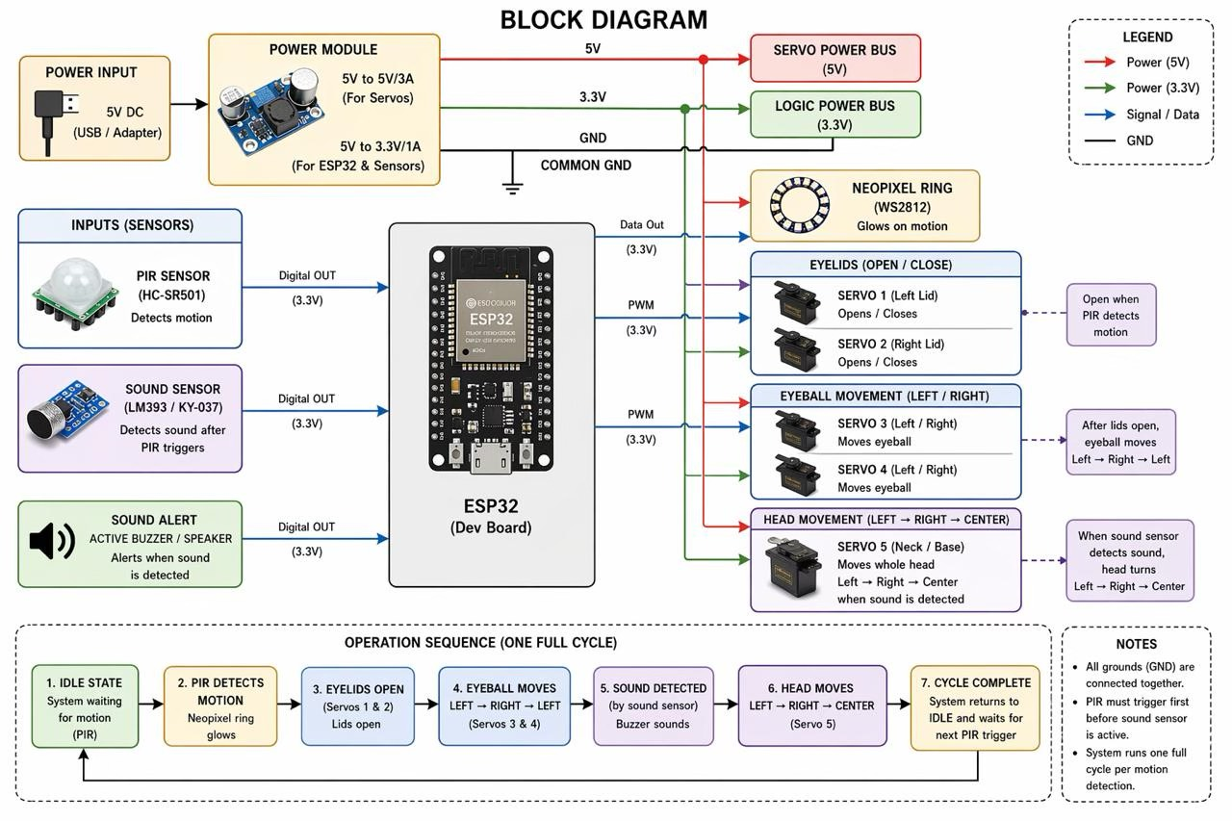

2. Components Table

Component | Quantity | Purpose | Justification
ESP32 Microcontroller | 1 | Acts as the central brain, processing sensor inputs and orchestrating all mechanical and visual outputs. | Offers ample GPIO pins with hardware PWM support needed to drive multiple servos simultaneously. It also provides the processing speed required to constantly poll sensors without lagging the motor routines.
Servo Motors | 5 | Actuates the physical movements of the robot's left eye, right eye, left eyelid, right eyelid, and head. | Servos provide precise, repeatable angular positioning out of the box. This is essential for giving the robot lifelike, expressive movements without the need to build complex custom feedback loops.
PIR Motion Sensor | 1 | Detects the presence of a person in front of the robot to trigger the interactive "wake" sequence. | Highly reliable for human body heat detection over a wide angle. It acts as an ideal, low-power trigger to pull the robot out of its resting state.
Sound Sensor Module | 1 | Listens for sharp noises while the robot is active to trigger the secondary head-turning routine. | Provides a simple binary signal when a volume threshold is crossed, allowing for easy integration into the ESP32's polling loop without requiring heavy audio processing.
Neo Pixel LED Array(8 LEDs) | 1 | Serves as a dynamic visual status indicator, pulsing green during head movements and turning red after prolonged inactivity. | Requires only a single data pin from the microcontroller while offering individual, full-color RGB control, maximizing visual impact while minimizing wiring clutter.
5V External Power Supply (Min. 3A) | 1 | Delivers the necessary electrical current to run the microcontroller, sensors, LEDs, and all five motors simultaneously. | Five servos moving at once will easily overwhelm a standard USB connection or the ESP32's onboard voltage regulator, causing immediate brownouts. A dedicated power source ensures system stability.

